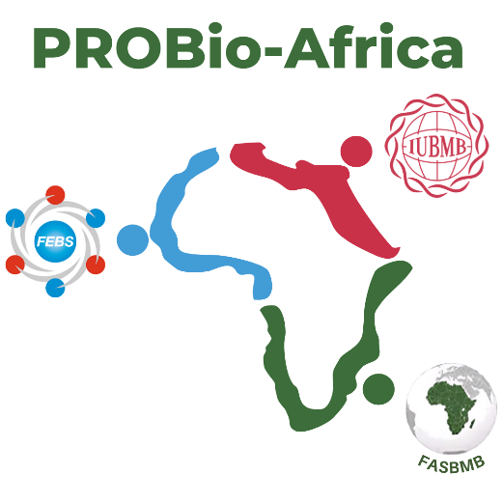
IUBMB-FEBS-FASBMB
PROBio-Africa Fellowships

Host mentor / laboratory information

NAME
AFFILIATION
(Institution / Address)
COUNTRY
CONTACT INFO
(email is obligatory)
WEB PAGE (of the host mentor or lab)
SCIENTIFIC INTERESTS (not more than 1000 characters w/o spaces)
FEBS National Society (of the host mentor)
OTHER RELEVANT INFO (optional)

Please fill out the form and send it to probio-africa@febs.org

